SUBMITTED BY:D VEERA HARSHA VARDHAN REDDY;210258

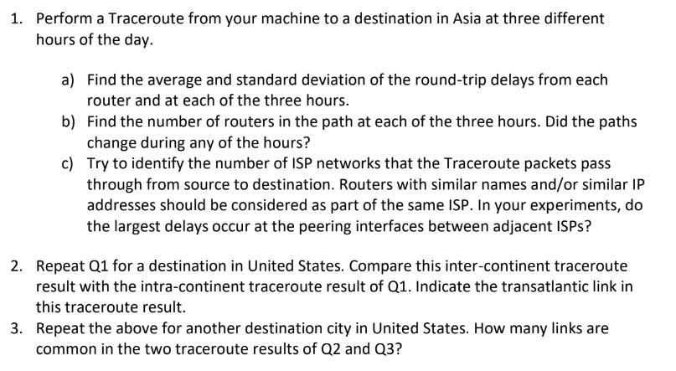TO ASIA:

9:20:

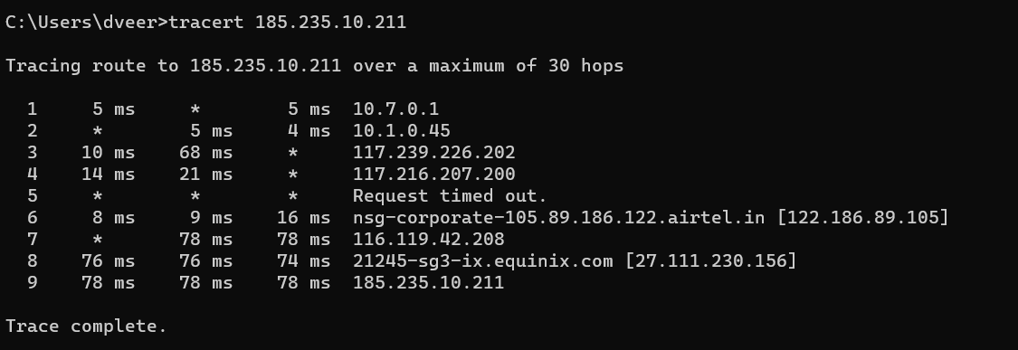

|  |  |
| --- | --- |
|  |  |
| mean | sd |
| 5 | 0 |
| 4.5 | 0.707106781 |
| 39 | 41.01219331 |
| 17.5 | 4.949747468 |
| * | * |
| 11 | 4.358898944 |
| 78 | 0 |
| 75.33333333 | 1.154700538 |
| 78 | 0 |

a)

12:15: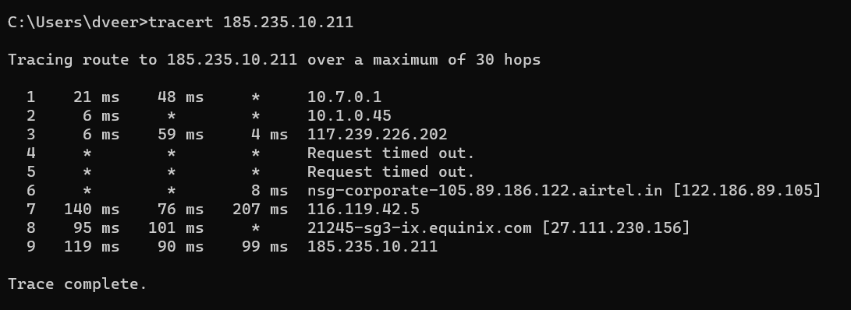

a)

|  |  |
| --- | --- |
| meaN | ST |
| 34.5 | 19.09188309 |
| 6 | 0 |
| 23 | 31.19294792 |
| * | * |
| * | * |
| 8 | 0 |
| 141 | 65.50572494 |
| 98 | 4.242640687 |
| 102.6666667 | 14.84362939 |

7:00pm:

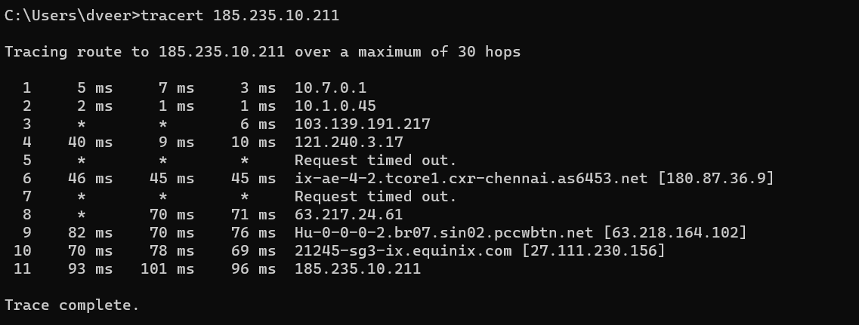

a)

|  |  |
| --- | --- |
| mean | sd |
| 5 | 2 |
| 1.333333333 | 0.577350269 |
| 6 | 0 |
| 19.66666667 | 17.61628035 |
| * | * |
| 45.33333333 | 0.577350269 |
| * | * |
| 70.5 | 0.707106781 |
| 76 | 6 |
| 72.33333333 | 4.932882862 |
| 96.66666667 | 4.041451884 |

b) Find the number of routers in the path at each of the three hours. Did the paths change during any of the hours?

Ans) For Time: 9:20 AM - Number of routers = 8

For Time: 12: 15 PM - Number of routers = 7

For Time: 7 PM - Number of routers = 9

No, the Path doesn’t change.

c)Try to identify the number of ISP networks that the Traceroute packets pass through from source to destination. Routers with similar names and/or similar IP addresses should be considered as part of the same ISP. In your experiments, do the largest delays occur at the peering interfaces between adjacent ISPs?

Ans) For Time: 9:20 AM - Total 8 ISPs with the destination. The largest delay occurred in between 2 & 3.

For Time: 12: 15 PM – Total 7 ISPs with the destination. The largest delay occurred in between 6 & 7.

For Time: 7 PM - Total 9 ISPs with the destination. The largest delay occurred in between 3 & 4.



TO UNITED STATES:

1. NEW YORK

9:20: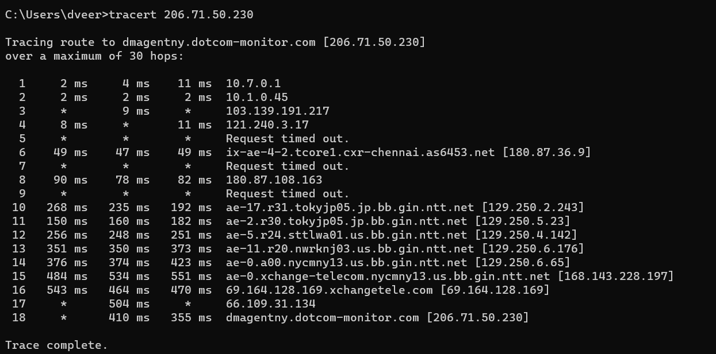

a)

|  |  |
| --- | --- |
| mean | sd |
| 5.666666667 | 4.725815626 |
| 2 | 0 |
| 9 | * |
| 9.5 | 2.121320344 |
| * | * |
| 48.33333333 | 1.154700538 |
| * | * |
| 83.33333333 | 6.110100927 |
| * | * |
| 231.6666667 | 38.10949138 |
| 164 | 16.37070554 |
| 251.6666667 | 4.041451884 |
| 358 | 13 |
| 391 | 27.73084925 |
| 523 | 34.82814953 |
| 492.3333333 | 43.98105653 |
| 504 | 0 |
| 382.5 | 38.89087297 |

12:15: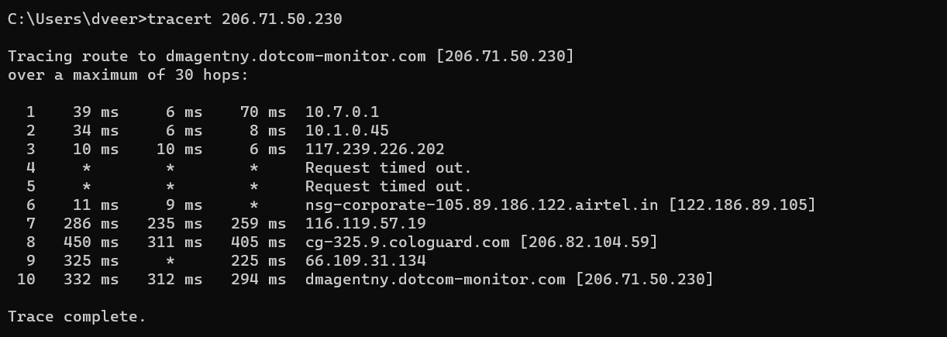

a)

|  |  |
| --- | --- |
| meaN | ST |
| 38.33333333 | 32.00520791 |
| 16 | 15.62049935 |
| 8.666666667 | 2.309401077 |
| * | * |
| * | * |
| 10 | 1.414213562 |
| 260 | 25.51470164 |
| 388.6666667 | 70.92484285 |
| 275 | 70.71067812 |
| 312.6666667 | 19.00876991 |

7:00pm: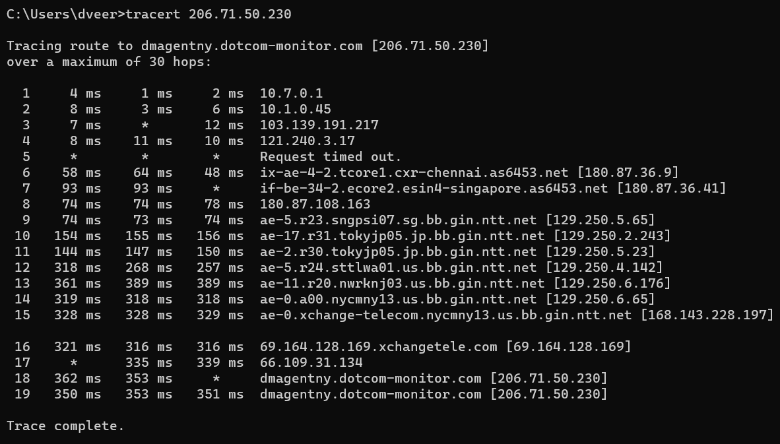

A)

|  |  |
| --- | --- |
| mean | sd |
| 2.333333333 | 1.527525232 |
| 5.666666667 | 2.516611478 |
| 9.5 | 3.535533906 |
| 9.666666667 | 1.527525232 |
| * | * |
| 56.66666667 | 8.082903769 |
| 93 | 0 |
| 75.33333333 | 2.309401077 |
| 73.66666667 | 0.577350269 |
| 154.3333333 | 0.577350269 |
| 281 | 32.51153641 |
| 379.6666667 | 16.16580754 |
| 318.3333333 | 0.577350269 |
| 328.3333333 | 0.577350269 |
| 317.6666667 | 2.886751346 |
| 337 | 2.828427125 |
| 357.5 | 6.363961031 |
| 351.3333333 | 1.527525232 |

b) Find the number of routers in the path at each of the three hours. Did the paths change during any of the hours?

Ans) For Time: 9:20 AM - Number of routers = 15

For Time: 12: 15 PM - Number of routers = 8

For Time: 7 PM - Number of routers = 18

No, the Path doesn’t change.

c)Try to identify the number of ISP networks that the Traceroute packets pass through from source to destination. Routers with similar names and/or similar IP addresses should be considered as part of the same ISP. In your experiments, do the largest delays occur at the peering interfaces between adjacent ISPs?

Ans) For Time: 9:20 AM - Total 10 ISPs with the destination. The largest delay occurred in between 8 & 10.

For Time: 12: 15 PM – Total 8 ISPs with the destination. The largest delay occurred in between 6 & 7.

For Time: 7 PM - Total 10 ISPs with the destination. The largest delay occurred in between 11& 12.

|  |  |  |
| --- | --- | --- |
| Hop No. | Avg Mean(ms) | Avg Std dev (ms) |
| Singapore | **38.54166667** | **14.07609296** |
| New York | **230.4** | **16.60947534** |

We can see that avg of New York is greater than avg of Singapore.

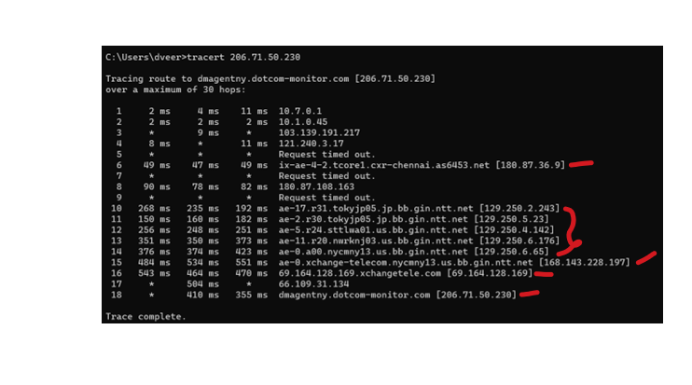

**Here the transitatlantic link in the traceroute result. As the link 11 there is a wide change in 12 and also in the following markings.**



TO STATES IN UNITED STATES:

SEATTLE

9:20: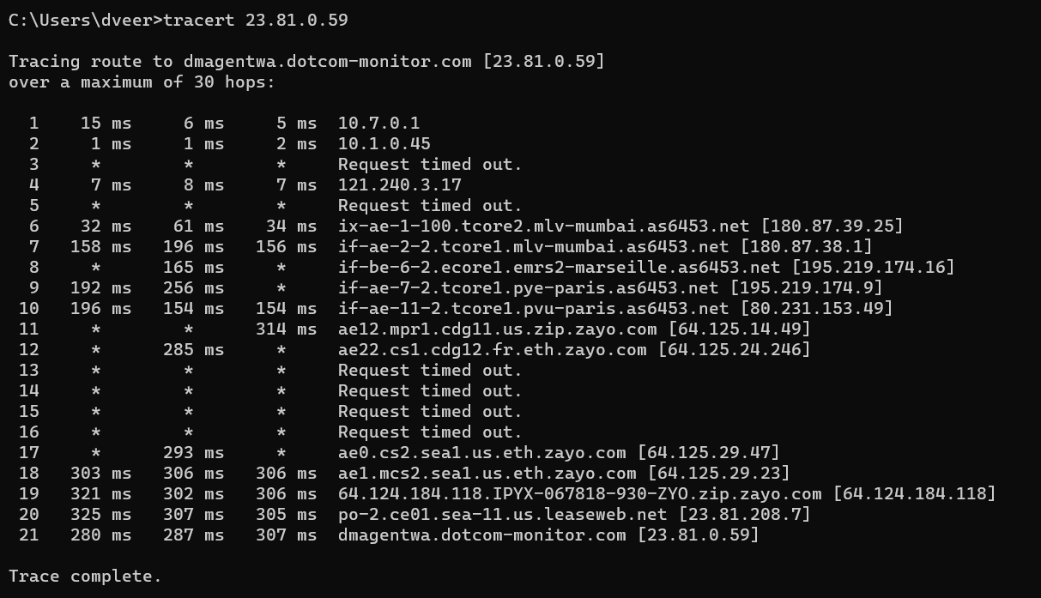

a)

|  |  |
| --- | --- |
| MEAN | SD |
| 8.666666667 | 5.507570547 |
| 1.333333333 | 0.577350269 |
| * | * |
| 7.333333333 | 0.577350269 |
| * | * |
| 42.33333333 | 16.19670748 |
| 170 | 22.53885534 |
| 165 | 0 |
| 224 | 45.254834 |
| 168 | 24.24871131 |
| 314 | 0 |
| 285 | 0 |
| * | * |
| * | * |
| * | * |
| * | * |
| 293 | 0 |
| 305 | 1.732050808 |
| 309.6666667 | 10.0166528 |
| 309.6666667 | 10.0166528 |
| 312.3333333 | 11.01514109 |
| 258 | 44.30575583 |
|  |  |

12:15:

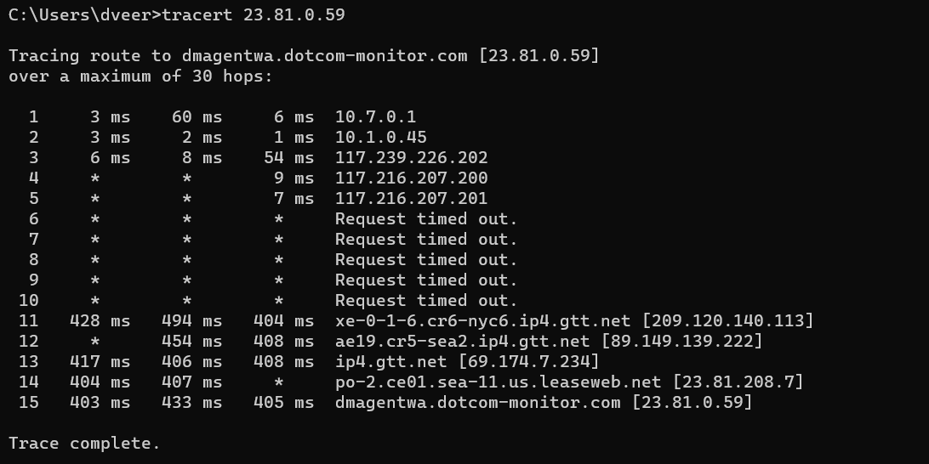

a)

|  |  |
| --- | --- |
| MEAN | SD |
| 23 | 32.07802986 |
| 2 | 1 |
| 22.66666667 | 27.15388247 |
| 9 | 0 |
| 7 | 0 |
| * | * |
| * | * |
| * | * |
| * | * |
| * | * |
| 442 | 46.60472079 |
| 431 | 32.52691193 |
| 410.3333333 | 5.859465277 |
| 405.5 | 2.121320344 |
| 413.6666667 | 16.77299417 |

7:00pm: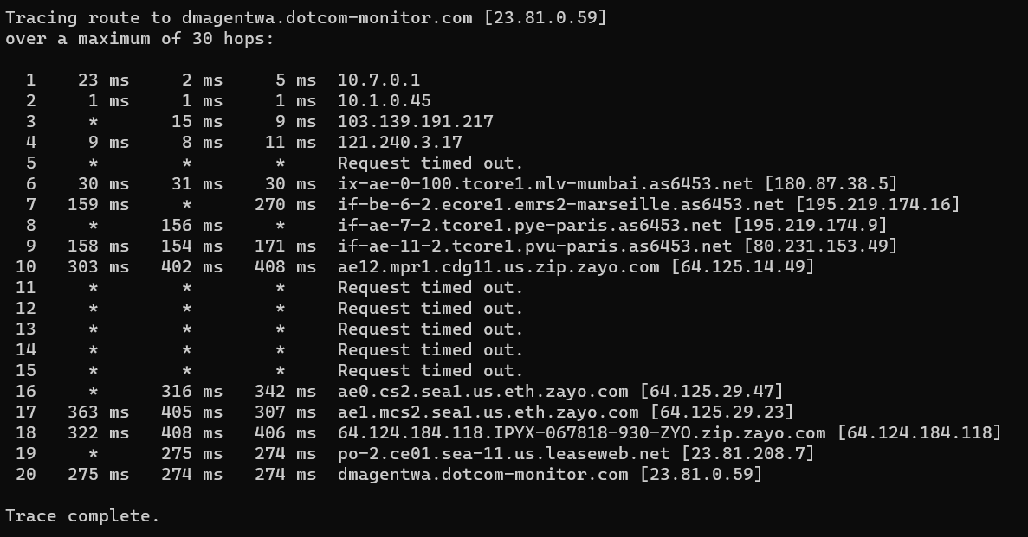

a)

|  |  |
| --- | --- |
| MEAN | SD |
| 10 | 11.35781669 |
| 1 | 0 |
| 12 | 4.242640687 |
| 9.333333333 | 1.527525232 |
| * | * |
| 30.33333333 | 0.577350269 |
| 214.5 | 78.48885271 |
| 156 | 0 |
| 161 | 8.888194417 |
| 371 | 58.96609195 |
| * | * |
| * | * |
| * | * |
| * | * |
| * | * |
| 329 | 18.38477631 |
| 358.3333333 | 49.16638418 |
| 378.6666667 | 49.08496036 |
| 274.5 | 0.707106781 |
| 274.3333333 | 0.577350269 |

b) Find the number of routers in the path at each of the three hours. Did the paths change during any of the hours?

Ans) For Time: 9:20 AM - Number of routers = 15

For Time: 12: 15 PM - Number of routers = 10

For Time: 7 PM - Number of routers = 14

No, the Path doesn’t change.

c)Try to identify the number of ISP networks that the Traceroute packets pass through from source to destination. Routers with similar names and/or similar IP addresses should be considered as part of the same ISP. In your experiments, do the largest delays occur at the peering interfaces between adjacent ISPs?

Ans) For Time: 9:20 AM - Total 9 ISPs with the destination. The largest delay occurred in between 17 & 18.

For Time: 12: 15 PM – Total 8 ISPs with the destination. The largest delay occurred in between 3 & 11.

For Time: 7 PM - Total 9 ISPs with the destination. The largest delay occurred in between 9& 10.

These are the common links in between Q2 and Q3:

Total 3 links

10.7.0.1

10.1.0.45

121.240.3.17